**Aim:** Multiply the following using Booth’s Algorithm

Multiplicand= +11 Multiplier= -6.

**Objective:** 1. To provide knowledge on signed and unsigned multiplications.

2. To learn procedure for binary multiplication using booth's algorithm.

**Theory:** Booth's multiplication algorithm is a [multiplication algorithm](https://en.wikipedia.org/wiki/Multiplication_algorithm) that multiplies two

signed [binary](https://en.wikipedia.org/wiki/Base_2) numbers in [two's complement notation](https://en.wikipedia.org/wiki/Two%27s_complement).

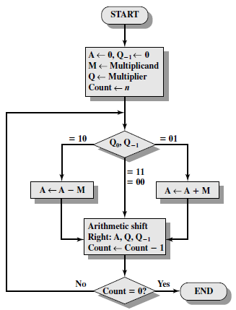

**Description:**

1. The multiplier and the multiplicand are placed in Q and M registers respectively.
2. There is also a 1-bit register placed logically to the right if the least significant bit Q0 of Q register and Q-1.
3. The results of multiplication will appear in A and Q registers.
4. A and Q-1  are initialize to 0.
5. Control logic scans the bits of multiplier one at at a time.
6. As each bit is examine the bit to its right is also examined.
7. If the two bits are same (i.e. 11 or 00), then all of the bits A,Q and Q-1 are shifted to right 1 bit.
8. If the two bits differ then the multiplicand is added to or subtracted from A register depending on whether the two bits are 01 or 10.
9. Following the addition or subtraction the right shift occurs .
10. In either cases the right shift is such that the left most bit of A namely An-1 not only is shifted into An-2 but also remains in An-1 .
11. This is require to preserve the sign of the number in A and Q.
12. It is known as arithmetic shift because it preserves the sign bit.

**Solution:**

Multiplicand= +11 (01011) , Multiplier= -6 (11011)

A=00000 , Q-1=0 , Q=11010 , M= 01011

|  |  |  |  |  |  |
| --- | --- | --- | --- | --- | --- |
| **A** | **Q** | **Q-1** | **M** | **Operation** | **Cycle No** |
|  |  |  |  |  |  |
| 00000 | 11010 | 0 | 01011 | Intial values |  |
|  |  |  |  |  |  |
| 00000 | 01101 | 0 | 01011 | Shift Right | 1 |
|  |  |  |  |  |  |
| 10101 | 01101 | 0 | 01011 | A=A-M | 2 |
| 11010 | 10110 | 1 | 01011 | Shift Right |  |
|  |  |  |  |  |  |
| 00101 | 10110 | 1 | 01011 | A=A+M | 3 |
| 00010 | 11011 | 0 | 01011 | Shift Right |  |
|  |  |  |  |  |  |
| 10111 | 11011 | 0 | 01011 | A=A-M | 4 |
| 11011 | 11101 | 1 | 01011 | Shift Right |  |
|  |  |  |  |  |  |
| 11101 | 11110 | 1 | 01011 | Shift Right | 5 |
|  |  |  |  |  |  |

Result in A and Q = 11101 11110

2’s complement = 00010 00010

Answer = -66

**Conclusion:** Thus, we studied how to perform Booth’s algorithm for 5 bit number using

2’s complement method.